AGENDA
RVDA OF SASKATCHEWAN ANNUAL GENERAL MEETING
Sept 16, 2026 10:30AM
Greenbrye Golf and Country Club, Saskatoon

ATTENDANCE

10:30AM CALL TO ORDER: introductions
Guest Speaker: Robyn Sather-Boswell Southeast Regional College RV Technician Foundation Program
11:00AM APPROVAL OF AGENDA
Vote by email: March 20-22 Move to Approve the Dealership Membership Application of Traveland RV Watrous to RVDA Sask.
Moved by: Allan Smith Second by: Thomas Cantafio carried.
Noted: Cameron Eddolls declared Conflict of Interest.

Voted by email: March 23 – 25 Motion is to approve the Dealer Member Application of FOUR SEASONS RV REGINA to RVDA Sask.
Moved by Kevin Cropper Second by Troy Palidwor carried.
Voted by email: April 7-10 Motion is to approve the ASSOCIATE Member Application of MOTOR SAFETY ASSOCIATION to Membership of Sask RVDA.
Moved by Kevin Cropper Second by Troy Palidwor carried
Voted by email: August 20-27 Motion is to Approve the Associate Membership Application of Wild Lakes Mobile RV Services (Darcy Skarra) to RVDA Sask and RVDA Canada.
Moved by Sarah Mass and second by Kevin Cropper. carried

MINUTES – Mar 11, 2025 (Attached)

TREASURER’S REPORT: update (Attached)

ASSOCIATION MANAGER REPORT – Nick Coroluick (Attached)

RVDA OF CANADA REPORT – Kyle Kehoe

PRESIDENT’S REPORT – Sarah Mass

UNFINISHED BUSINESS
- Website Progress to date

- RV Dealers Convention/Expo Nov 10-14 Las Vegas report. Kyle, Sarah and Nick comments. 2026

- Training rebates 2026

- 2026 Annual RV Technician Award

NEW BUSINESS
- Lippert Training : Jan 19 2027 Kehoe RV Saskatoon; Jan 21 2027 Village RV Regina

- Election: Kevin Cropper Director term expires in 2026. Nominations for Director for 2 year term.

ANY OTHER BUSINESS:
- Southeast Regional College RV Technician Foundation Program: motion to Progress to production and obtain sponsorships.

- SGI Technician Committee Report: Volunteers: Matt Schaan Traveland Martensville and Brett Gelowitz and Mitch Peterson Village RV Regina First meeting Sept. 15

- SGI Negotiation Committee: Committee members: Brett Gelowtiz, Cameron Eddolls, Geri Sauer, Nick Coroluick Association Manager Ex Officio members - Sarah Mass as President of RVDA Sask and Dwight Carsen (will attend a couple meetings). First meeting to be announced.

NEXT MEETING – Tues Nov 3, Wed 4 or Thurs 5 2026 General meeting Regina

ADJOURNMENT

MINUTES OF
RVDA OF SASKATCHEWAN GENERAL MEETING
1:00 p.m., Wednesday, March 11, 2026
Greenbrye Golf and Country Club, Saskatoon

ATTENDANCE:
Sarah Mass | Affordable Trailer Sales | Kyle Kehoe | Kehoe RV
Troy Palidwor | Credit Union Finance | Michael Hardy (Guest) | Ia
Allan Smith | Ia | Nathan Saggs (in place of Thomas Cantafio) | First Canadian
Brett Gelowitz (in place of Larry Ortman) | Village RV | Cam Eddolls | Traveland
Dale Diakow | RBC | Patti Gryzbowski | Sunridge RV
Karl Ray | Mr. RV | Jon Lozowchuk | Lloyd Autobody&RV
Geri Sauer | Prince Albert RV | Eli Backous | Lloyd Autobody&RV
Larry Friesen | Prairie RV & Trailer | Graeme Sauer | Prince Albert RV
Regrets: Jordan Morrisey | Precision RV & Trailer | Regrets: Kevin Cropper | Cropper Motors

1:00PM CALL TO ORDER
Guest Speaker: Harvard Media – Zak Rempel (Director of Enterprise Sales)Digital marketing; - general comment: Marketing is changing, average person spends about 6 hours /day consuming media; 74% of buyers – research brands before purchasing. – trend is increasing. Zak showed psychology of the new shopper/buyer and concepts on how to reach them; Top of funnel: creates demand and attracts potential future buyers. ; middle of Funnel- helps buyers evaluate options and move toward a dealership; bottom of Funnel – converts high intent buyers into leads or visits.
New members: Jon Lozowchuk and Eli Backous from Lloyd RV and Autobody; Geri Sauer and Graeme Sauer from Prince Albert RV
Motion to approve AGENDA:
Moved: Allan Smith Second: Cameron Eddolls carried
Motion to approve MINUTES – November 6, 2025
Moved: Karl Ray Second: Patti Gryzbowksi carried
Motion to approve the 2025 Year End Final Report
Moved: Graeme Sauer Second: Allan Smith carried

ASSOCIATION MANAGER REPORT – Nick Coroluick (condensed format attached – contact Nick if you wish the full report)
RVDA OF CANADA REPORT – Kyle Kehoe (condensed format attached – contact Nick if you wish the full report)
PRESIDENT’S REPORT - Sarah Mass (condensed format attached – contact Nick if you wish the full report)

UNFINISHED BUSINESS
Website Progress to date (member volunteers to help – Brent Mass and Olivia Dunn) the focus of our New Website will be to our RV customers and to lead them to our RV Dealers and Associates for Sales or for Service. We will have space to promote at least one sale per year per dealer; and Ads will also be available for purchase for members and non members. There will be a Members Only page in order to share things that are unique only to our Members – ie: special promotions, minutes of meetings, announcements etc. TARGET DATE FOR LIVE PUBLISHING IS MAY 1 2026; NEEDS FROM MEMBERSHIP: website address; contact name; CLEAN LOGO – with lots of white space around.

RV Dealers Convention/Expo Nov 10-14 Las Vegas report. Kyle, Sarah and Nick comments on the 2025 conference. 2026 Expo dates: Nov 9-13 will be in Las Vegas at Paris Hotel. Encourage ALL members to consider this at least once to experience the value.

Training rebates 2026 The following is our program for 2026:

2026 Reimbursement of costs for Training. (a Maximum of $1000.00 for training expenses (receipts must accompany application to each Dealer Member and Associate / SERVICE Member. Receipts must accompany the application.

2026 ANNUAL RV TECHNICIAN AWARD 2 awards of $250.00 each to maximum of 1 technician per Dealer Member. (purpose to assist for reimbursement of tool purchase in year 2026). Dealer will nominate the technician. Receipts must accompany the application and photo of technician is required on acceptance for publication . {maximum cost per year $ 500.00}

NEW BUSINESS
Training for 2026: Karl Ray (Mr RV) and Mitch Peterson (Village RV) are looking thru a spreadsheet of options for the 2026 year. Once we have their comments, Nick will contact the selected ones to see if a training program can be done in Nov, Dec or Jan. ; suggestion from the meeting- HWH, and to consider General Sharing from the Membership – possibly Best Practises etc.
ANY OTHER BUSINESS:
GENERAL BRAINSTORMING FOR SGI NEGOTIATIONS: Tremendous discussions – ideas shared – consider annual agreement as opposed to 2 years; Jon suggested we join the meeting with Heavy Truck negotiation with SGI (Jon will confirm if we will be allowed to observe the meeting on March 25 in Saskatoon)- they have been more successful in achieving higher rates; it was discussed to have member sharing (ie: Sarah Mass and Brett Gelowitz) on efficient ways to apply for all items that are invested;
- Average door rate for the 7 Accredited shops in attendance is: $158.29 per hour (SGI rate: $104.31 for Category A; $100.10 for Category B).
- Comments listed: (noted to those that recorded comments – I have edited some but others that I wasn’t sure of the concept – the following comments are verbatim:
-Why do we need to be Accredited EVERY year, why not every 2 to 3 years?
-There should be a standardized rate book, so everyone is on a level playing field.
-Create an RVDA SGI committee that meets Annually with SGI and discusses issues. Manitoba Public Insurance pays 106 /hour and ICBC pays 169.00 per hour, If based on population VS Insurance Rate, Sask should be at least $140.00 per hour.
- dicor sealent; ?? –fees – upcharges - best for services – SGI – book
Also: thankyou Jon for bringing the documents from the different insurance companies that you have billed, good background for us.
Nick will be speaking with Dwight Carsen our past negotiator and will also be in touch with Jon regarding the meeting with the Heavy Truck association – the following members have volunteered to work on a committee for next year rates: Cam Eddolls, Jon Lozowchuk, Graeme Sauer, and Eli Backous.

NEXT MEETING – Sept 16 2026 AGM and Golf Tournament Greenbryre Golf and Country

ADJOURNMENT 3:15PM

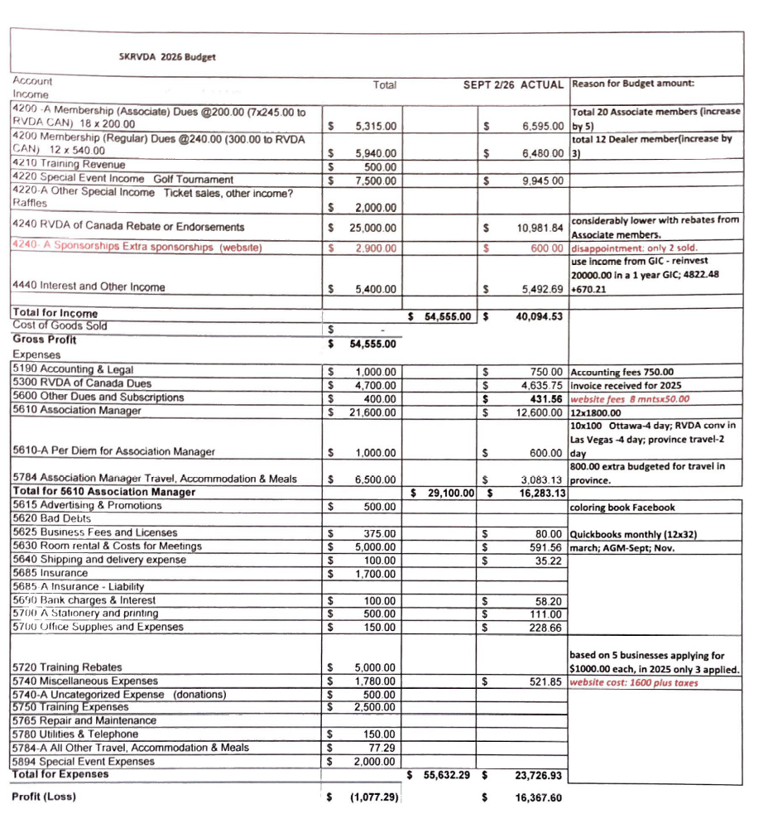

Manager Report AGM 2026
Dealer Membership – 12 members, please welcome our 3 Newest and Renewed Members: Four Seasons RV Regina, Traveland RV Watrous, and Renewed Member Frank Dunn RV from Prince Albert.
Associate Membership – 20 members, please welcome the 5 new 2026 members: Lloydminster Auto Body and RV, Motor Safety Association, Prince Albert RV, RV Universe and Wild Lake Mobile Services. I personally am very proud to welcome these eight new members to the Saskatchewan RV Dealers Association. Some of them have already shared some ideas and are prepared to work with us to bring fresh ideas, new perspectives, and stronger engagement to our industry.
Thankyou all for being prompt with your dues, it helps our cash flow immensely.
A quick recap of the Association Activities to date:
- I have visited ALL Dealer Members except for 3 as of Aug 18. I thank you all for your hospitality when I showed up and I hope that this can be an annual event for the Association Manager. It’s important to get to know you individually and to visit your business.
- The RVDA Canada meeting in April was a great experience for me. Getting to know the National members of the Board as well as the other Executive Directors gives me a larger network for information on helping our members. Also, we were able to join the Advocacy group and discussed our needs with a large number of the Federal Government MPs. (Thankyou to Kyle Kehoe, RVDA Canada rep, and Paul Mass, Affordable Trailer Sales, for being a part of the Advocacy as well as his normal duties with the Education committee.)
- Kristin Lauer with Lippert has accepted Training for our techs this year. Class Subject: Schwintek Slide-outs, Furrion Water Heaters, Furrion Refrigerators. Classes will be January 19,2027 at Kehoe RV Saskatoon and Jan 21, 2027 and at Village RV Regina. Mark your calendars! More info to follow.
- Due to our excellent discussion at our March meeting, we have been able to form a Technical Committee with SGI. I had sent out requests for a couple volunteers to work on this committee and we have our first meeting arranged for Sept 15 in Saskatoon. Thankyou Brett Gelowitz and Mitch Peterson (Village RV) and Matt Schaan (Traveland RV Martensville) for volunteering. Our contact in SGI is Gary Paulson. The following is the committee description sent out by Gary to invite us to the first meeting. ‘It has been several years since the RVDA group last met, and I would like to bring everyone together to reconnect and discuss current issues, opportunities, and priorities affecting our work. This meeting will provide an opportunity to share updates, discuss any challenges or concerns, and identify areas where we can work together moving forward.’
- We have formed a SGI Negotiating Committee to begin work on discussing the rates being paid by SGI to our members when repairing their insured units. This will be a more active committee of an expected 8+ meetings but ultimately I hope our relationship and our past history will result in a profitable negotiation. Committee members are: Brett Gelowtiz, Cameron Eddolls, Geri Sauer, Nick Coroluick Association Manager; as well; as Ex Officio members - Sarah Mass as President of RVDA Sask and Dwight Carsen (will attend one or two meetings at the beginning.
I have been in contact with members of the Manitoba RVDA and they have recently settled with their Public Insurance company as well as members of the BC RVDA as they have agreements with the BC Government Insurance. Manitoba reimbursement rates are slightly better than ours but their Accredited Dealers have also been given the Mitchell RV Estimating program to assist in their invoicing and applying for their reimbursement, making things not only more efficient but, also, helps mitigate improper adjustments. And, BC has a considerably more lucrative arrangement with their Govt Insurance.
- Finally, probably my most exciting news. For many years, the Saskatchewan RVDA has recognized the need for a provincial RV technician training program. Previous attempts never advanced far enough to develop a formal curriculum. This year, we have made significant progress by partnering with Robyn Sather-Bothwell of Southeast Regional College (thankyou to Brett Gelowitz and Mitch Peterson from Village RV for working on this to date) and have developed an intense eight-week Foundation RV Technician Program. The next phase of the project involves securing classroom space, recruiting qualified instructors, and obtaining the funding necessary to launch the program. I hope you will attend the AGM as Robyn will be speaking about this unique-to-Saskatchewan program.
I sent out a survey to all Service and Dealer members in July and have found that there is a clear and growing demand for trained RV technicians across Saskatchewan. As each of you Employers are aware, many dealerships must train new employees entirely on the job, requiring significant investments of both time and resources. Our goal is to create a program that provides employers with entry-level technicians who possess fundamental skills and can become productive members of the workforce from their very first day.
We believe this initiative will strengthen our industry by creating a reliable pipeline of future technicians while reducing training costs for our member dealerships. There is no doubt that each graduate of our first number of classes will have employment opportunities immediately on completing the course.

- We are registered once again in the Province with ISC as a Non Profit Business. This gives us more legitimacy as we look for benefits as Non Profit organization to serve our members. This doesn’t mean that we cannot earn sufficient income to have invested as long as we are showing that the money is meant for our members.

- Our new website is up and running, I realize there is still some fine tuning and I am slowly learning how to complete some of these administrative duties, BUT I am thrilled with the fact that we can update the website ourselves to keep it totally current and with the proper Admin staff in future, you will be able to be much more creative and have it more active by our customers. I ask that each of you add our website link to your website, this will give our customers a purpose for checking us out as well.
Respectfully submitted,
Nick Coroluick
Association Manager
Saskatchewan RV Dealers Association

